PROVIDENCE HOUSING AUTHORITY

RESIDENT SERVICES
BOARD OF COMMISSIONERS SUBCOMMITTEE MEETING
Major Projects Report-COVID 19
June 25, 2020

RESIDENT SERVICES DEPARTMENT

COVID 19 Updates:
The RSD’s approach to COVID 19 has been to serve Residents through an interdepartmental approach.
- Emergency Resident Outreach Log (EROL)-The EROL targeting all public housing residents started at the beginning of the crisis and has evolved with multiple phases. The Outreach was not only a completely new way to outreach to residents, it is a new way to share information collaboratively among departments.
The approach to this outreach and the follow-up outreach phases continues to be; to state the purpose of the outreach, create teams by identifying staff across departments to participate, create a standard operating procedure (SOP) that aligns with the purpose of the outreach, create consistent messaging for staff to use with a common script, create a tracking spreadsheet that aligns with the questions on the script, and create and update a universal Resource Guide to share with Residents.
PHASE 1 started on Monday, March 20, 2020: All public housing household were called and information on calls and attempted calls were tracked, in addition to other indicators.
PHASE 2 all public housing resident calls were completed by Friday, April 24, 2020. The Property Management staff was asked to input data and update the public housing software system (HAB) with the contact information collected from the resident survey including the main phone, second phone, emergency contact and email.

PHASE 3 The PHA mailed outreach questions to the residents not contacted through calls. Residents had the option to answer questions on-line through a doodle poll or by returning a paper copy to the office. PM staff is updating information into the log and into HAB. PHASE 3 outreach is approximately 91%. This log is where the Food delivery is tracked. See the table in Food Task Force and Delivery Service.

PHASE 4 the PHA began work on the Leased Housing Outreach Log was on May 8th. RSD staff who had also made the Public Housing calls, called Section 8 participants to share important resources and gather similar information. Staff are also asking, after consultation with Legal Counsel about whether individuals would be willing to self-report positive cases.
PHASE 5: The Leased Housing Reps identified those on their caseload not contacted with an initial call and mailed outreach questions to the Leased Housing participants. Leased Housing participants will have the option to answer questions on-line through a doodle poll or by returning a paper copy to the office. LH staff will update information into the log and into HAB. This information is shared in the table below.
PHASE 6 continuous improvement: The Office of Strategy and Development identified CallMax as the vendor/system to do mass callings to developments on a variety of issues including but not limited to; FM operations information, COVID testing at Carroll Tower, Food delivery at Codding Court. , or future topics such as voter registration reminders.

LEASED HOUSING
Leased Housing | Total # of Leased Housing participants on Contact List | Number of Leased Housing participants with Direct staff contact
Leased Housing  LH participants no contacted 409/2132=19% (paper survey sent 6/17)) | 2,132 | 1,723 (81%)
PBV  PBV participants not contacted 216/345 = 63% (paper survey sent 6/17) | 345 | 129 (37%)
Total | 2,477 | 1,852 (75%)

Additional Resident Outreach:
- PHA established its own COVID 19 Hotline: During the week of April 13th, and as COVID 19 cases increased dramatically in Rhode Island and Providence, leadership recognized the need to reach out to Residents. Postcards went out to the PHA on Saturday, May 2nd for Residents to self-report, it included a staff name and Parenti office number. Residents can share COVID 19 testing information, and the PHA can follow up and share or find additional resources to help them keep their quarantine. The information in this document is confidential. This tracking sheet is a shared document with Directors, who are using the information to ensure staff safety. Resident Service staff has been assigned to check the tracking sheet every half hour, to update information, and offer additional supports to Residents on the COVID 19 positive list. A Standard Operating Procedure has been created, so that at this check in, if there is a new person added, the RSD staff will reach out to the Resident with a series of questions that the resident can voluntarily answer regarding time of quarantine and any additional supports the resident may need.
- Food Task Force and Delivery Service –This interdepartmental project relied on input and leadership from Facilities Management for production and distribution, Property Management for information on individual cases of need, OSD for funding from Rhode Island Foundation, Finance for procurement and funding management, Resident Services for resident outreach, and distribution. Two Standard Operating Procedures have been created; one for the creation of the Food Task Force, and one for the Distribution.
Development | Date | Number Delivered |  | Food supplied by*
Sunset Village | 3/23 | 24 |  | PHA
Codding Court | 3/25 | 21 |  | PHA
Carroll Tower | 3/27 | 16 |  | PHA
Kilmartin Plaza | 3/27 | 72 |  | PHA
Hartford Tower | 3/30 | 61 |  | PHA
TOTAL FOR MARCH | 194
Parenti Villa | 4/7 | 35 |  | RI Comm. Food Bank (RIFB)
Dominica Manor | 4/8 | 70 |  | RIFB
Carroll Tower | 4/9 | 99 |  | PHA
Dexter Manor | 4/10 | 60 |  | RIFB
Dexter Manor | 4/21 | 75 |  | PHA
Dominica Manor | 4/21 | 52 |  | PHA
Sunset Village | 4/23 | 24 |  | PHA
Kilmartin Plaza | 4/23 | 82 |  | PHA
Carroll Tower | 4/23 | 1 |  | PHA
Hartford Park Family |  | 2 |  | PHA
Manton Heights |  | 1 |  | PHA
Section 8 |  | 1 |  | PHA
TOTAL FOR APRIL PHA SUPPLIED | 337
TOTAL FOR APRIL RIFB SUPPLIED | 165
Parenti Villa | 5/5 | 25 |  | RIFB
 |  | 25 |  | Frozen meals (City)
Dominica Manor | 5/6 | 70 |  | RIFB
 |  | 70 |  | Frozen meals (City)
Dexter Manor | 5/6 | 51 |  | RIFB
 |  | 51 |  | Frozen meals (City)
Carroll Tower | 5/12 | 87 |  | PHA
 |  | 70 |  | Frozen meals (City)
Dominica Manor | 5/13 | 40 |  | PHA
 |  | 40 |  | Frozen meals (City)
Dexter Manor | 5/13 | 76 |  | PHA
 |  | 11 |  | RIFB
 |  | 76 |  | Frozen meals (City)
Sunset Village | 5/14 | 24 |  | PHA
 |  | 24 |  | Frozen meals (City)
Kilmartin Plaza | 5/14 | 72 |  | PHA
 |  | 72 |  | Frozen meals (City)
Hartford Park family (2)/Codding Court (2)** |  | 3 |  | PHA
Hartford Park family (16)/Codding Court (2)** |  | 18 |  | Frozen meals (City)
SS** |  | 2 |  | PHA
SS** |  | 16 |  | Frozen meals (City)
S8** |  | 1 |  | PHA
Codding Court | 5/19 | 29 |  | PHA
Dexter Manor | 5/20 | 38 |  | PHA
 |  | 14 |  | RIFB
Parenti Villa | 5/21 | 65 |  | PHA
 |  | 16 |  | RIFB
Hartford Tower | 5/23 | 63 |  | PHA
Dexter Manor | 5/27 | 22 |  | PHA
Carroll Tower Resident | 5/27 | 2 |  | PHA
Codding Court | 5/28 | 57 |  | YMCA
TOTAL FOR MAY PHA SUPPLIED | 524
TOTAL FOR MAY RIFB SUPPLIED | 187
TOTAL FOR MAY FROZEN MEALS(CITY) | 462
TOTAL-TO-DATE FACE MASKS | 174 |  |  | Dexter Manor
TOTAL TO DATE FOOD BOXES (PHA/RIFB) | 1,158
Parenti Villa | 6/2 |  | 39 | RIFB
Dominica Manor | 6/3 |  | 70 | RIFB
 |  |  | 70 | Frozen meals (City)
Dexter Manor | 6/3 |  | 60 | RIFB
 |  |  | 60 | Frozen Meals (City)
Hartford Park family | 6/4 |  | 1 | PHA
Codding Court | 6/4 |  | 70 | YMCA
Dominica Manor | 6/10 |  | 55 | PHA
 |  |  | 55 | Frozen meals (City)
Dexter Manor | 6/10 |  | 77 | PHA
 |  |  | 77 | Frozen meals (City)
Sunset Village | 6/11 |  | 24 | PHA
 |  |  | 24 | Frozen meals (City)
Kilmartin Plaza | 6/11 |  | 64 | PHA
 |  |  | 64 | Frozen meals (City)
Codding Court | 6/11 |  | 58 | YMCA
Parenti Villa and Codding Court | 6/4 |  | 100 loaves of bread total | WBNA/Seven Stars bakery
TOTAL TO-DATE PHA SUPPLIED** | 1,276
TOTAL TO-DATE RIFB SUPPLIED** | 521
TOTAL TO-DATE FROZEN MEALS(CITY) | 736
TOTAL TO-DATE YMCA* | 185 |  |  | Codding Court
TOTAL-TO-DATE FACE MASKS | 204 |  |  | Dexter Manor
TOTAL TO DATE FOOD BOXES (PHA/RIFB) | 1,797
**All DELIVERIES made by PHA staff *PHA staff assisted delivery

Other Food Programs:

Frozen meals from the City of Providence: PM staff picked up an additional 300 meals to distribute.

Sodexo: Tuesdays and Fridays from 11am-2pm at 50/40 Laurel Hill Ave parking lot 2 meals a day for 3 days for children under 18 years old
.
YMCA: Food delivery to all Codding Court residents for 5-weeks, every Thursday starting May 28. The food distribution will alternate each week between a grocery bag one week, and a box that will enable a family to cook a hot meal for 5 individuals.

WBNA/Seven Stars Bakery: donated 100 loaves of bread for a June 4th bread delivery to Parenti Villa. 25 loaves of bread were distributed at Parenti Villa, and 75 at Codding Court during the YMCA’s food delivery.

Program Updates:
4. Jobs Plus Providence (JPP) Program
- HUD Jobs Plus Intensive Outreach:
  - Property Managers in MH and HP are starting their JPP JPEID Interim Interviews. We implemented new strategy to expand our financial coaching services and aid those with a financial hardship. Residents that have a significant increase in their rent due to the end of JPEID will be referred to our Financial Coach (FC). The FC will be working with resident’s one-on-one, reviewing their credit, and establishing a livable/manageable budget. A spreadsheet was created to keep track of referrals and the residents' progress.
  - Unemployment Insurance Applications
- Partnerships
  - Providence Public Library (PPL) – is supporting on-going computer literacy through on-line teacher guided learning.
  - Progreso Latino-is supporting adult HSE learning through on-line teacher guided learning
  - Young Voices-is developing a distance learning program for their summer youth leadership
- One Providence Summer Youth Internship
  - The team is creating alternative programming for summer learning scheduled to start July 6th. The City determined that this would be an on-line career readiness learning program rather than the traditional internship experience. Staff will be working in groups and one-on-one through zoom to have youth develop individualized projects for career exploration. Youth will complete the online talent assessment (formerly the Clifton StrengthsFinder) to, discover what you naturally do best, learn how to develop your greatest talents into strengths, and use your personalized results and reports to maximize your potential. We are engaging a Strengths-finder coach to work with youth to identify how to best use their strengths in a work environment. The Providence Public Library (PPL) offered to provide classes for our summer youth-at no cost to us. The classes will be twice a week and by the end of the summer they will have at least 2 NorthStar certifications. The curriculum will also include career exploration and assisting youth with creating a resume.

5. FSS
- Remote services, with check in calls every week or every two weeks depending on client need.
- Update HUD waiver for FSS program
  - There have been 5 positive terminations (3 Section 8 and 2 Public Housing)
  - There have been no extension requests
- Success story: Largest FSS escrow disbursement
FSS SUCCESS STORY: CANDIDA COOPER
Candida Cooper, a 27-year-old single mom of 4 boys who has lived in Chad Brown over 10 years, arrived in the FSS office unemployed with no income but the desire to better her life. Candida had decided she wanted to change her life for the better and give her boys the opportunity of a better life. That day, she talked about the possibility of moving out of Chad Brown, out of the public housing world and maybe chasing the dream of becoming a homeowner. Candida signed the FSS contract and became official participant on December 2015. Soon after, she became employed with the Postal service as a mail carrier. Being a devoted mom, she proved also to be a devoted employee, and Candida has maintained employment for the 5 years of her contract. She was determined to be a success, and stayed focused on her goals and kept all mandatory Progress reports with her FSS Coordinator. Candida is our prized participant, as she is taking the largest escrow check in the history of Providence Housing Authority. Due to her hard work and dedication to the FSS program Candida’s escrow check totaled $42,348.43. Candida has begun the process of cleaning her credit by paying off her debt, thus increasing her credit score. With her escrow money she plans on paying off her car loan and putting down a deposit towards her first home. Upon receiving her check Candida expressed her sincere appreciation for the FSS program and asked if she could sign up again. While she cannot re-enroll in FSS, she can be an inspiration to many in the PHA community.

6. Resident Service Coordinator (RSC) Program
- Remote support to caseload clients
- Unemployment Application support
- Family RSC’s are reviewing the recent HUD data guide and establishing a draft Standard Operating Procedure (SOP) for data entry into the HUD InForm tracking tool.
- Strong Families event – on hold
- Spring Health fairs - on hold

7. Wellness Coordinator
- Remote services-including on-line group meetings. The Hartford Tower group meets on Thursdays and there have been 5 consistent participants.
- Resource list sent to all Wellness Center clients that includes zoom links to AA and NA meetings.
- Intensive follow up

8. VOCA Coordinator
- 108 Residents have been served by this program to-date.
- Continuous review of weekly Security Reports, to offer remote services
- Leading development of a process for reviewing Security Reports with Wellness Coordinator for a coordinated and comprehensive approach to Resident Outreach.
- Intensive follow up
- Has encouraged participation in on-line group meetings
- Development of on-line workshops and support groups

9. Adult Education Program
- Genesis Center-conducting on-line distance learning for Adult Basic Education classes and phoneline conferences to work collaboratively on outreach and recruitment for programs

10. VITA
- On hold-deadline extension until July 15 for filing
- Staff changed the signage on the building to reflect the new deadline, changed the voice message at the PHA regarding the new deadline, and shared that Federal Hill House is still offering services.

11. Financial Opportunity Center (FOC)/Homeownership Program
- First Time Homebuyer Fair-on hold
- Unemployment Application support
- Restructuring the FOC program to offer Financial Coaching more broadly to various residents. Pilot project in development to make strategic referrals to the Financial Coach for Residents with a payment plan resulting from the COVID 19 impact.

12. RSD Partnerships
- Boys and Girls Club-Their plan is due to DHS on June 1st. The Boys and Girls Club is planning on offering summer programming only at one of their 3 sites in response to program delivery changes required.
- Head Start-Setting up a phone conference to work together to share messaging to Residents for their new program delivery.
- Family Service of Rhode Island Be Safe Plus program - a service providing deliveries of fresh foods and cleaning supplies to elderly and disabled residents. Boxes of fresh foods along with safety supplies like masks, hand sanitizer, toilet paper and more delivered to residents who register with The Point. We are piloting a collaboration of messaging registering for this program together with our food delivery at Hartford Tower.
- Other Partnerships as described in Jobs Plus

OFFICE OF STRATEGY AND DEVELOPMENT
GRANTS
Just as this report was going to press, PHA learned on June 18 that it was awarded $75,000 from the RI Foundation’s special COVID-19 Behavioral Health Fund to hire an MSW Social Worker to serve as an internal source of expertise about Covid-19-related trauma, coach PHA Resident Service Coordinators in making referrals to and navigating the behavioral healthcare system, triage Covid-19 related referrals from PHA staff to behavioral health agencies to lessen the impact of multiple staff making referrals to outside organizations, and follow up on Covid-19 referrals to ensure residents have engaged with a provider. This will be an excellent opportunity over the next year to deepen the PHA’s recent work on mental and behavioral health needs of its residents.

PHA has been awarded an AmeriCorps member through NeighborWorks Blackstone River Valley’s Accessing Home Program and are now looking to select a member. The AmeriCorps member will work with OSD and the Leased Housing department to advance the PHA’s landlord outreach and recruitment efforts. S/he will also work to help secure housing and other needed services for hard-to-house tenants in a few of the PHA’s special voucher programs, including the Mainstream Voucher program for families with a non-elderly disabled adult who are experiencing homelessness, and the VASH program for disabled veterans.
OSD and Resident Services have submitted a $25,000 grant request to the United Way of RI for its RI Recovers RFP to support agencies adjusting to the impacts of COVID-19. The funding would support an Employment Case Manager position to work with residents who are seeking employment opportunities.
We also recently submitted a request for a third year of funding for the Victims of Crime Act program, requesting $159,802. Our current VOCA funding runs until February 28, 2021 but this request if funded would extend our program through next year.
We are waiting to hear back on the request noted last month to the RI Foundation for its COVID behavioral health grant fund to expand efforts to work with tenants experiencing challenges in this difficult time.
RESIDENT ADVISORY BOARD
We continue to work closely with the RAB – holding several calls every week to check in with groups of RAB members as well as a monthly call. We also held a full RAB meeting on June 17th and the RAB determined it wants to continue meeting through the summer. At the June 17 meeting the RAB heard from Allan Pacific on facilities improvement projects planned for the summer and beyond, received other general updates from OSD, and shared their input on their roles as RAB members in their communities.

COMMUNICATIONS AND OUTREACH
CALLMAX - OSD has taken on the outreach to tenants on a large scale through use of the new mass messaging service, CallMax. We have been sending phone, text, and email messages to tenants throughout the developments and some messages to Section 8 residents. For many phone calls we have been doing follow up calls to those tenants whose phones were busy or did not receive a message when the mass call went out (for instance, those who did not pick up the phone and also do not have voicemail). Examples of recent mass messages include:
Delivery of food and other essentials: Informing residents on the timing of PHA food box delivery at all elderly/disabled buildings, RI Community Food Bank senior box delivery (done by PHA staff) at Dexter, Dominica and Parenti; YMCA food delivery weekly from late May to late June at Codding Court; and a one-time delivery of fresh bread from Seven Stars Bakery at Parenti Villa. We also are partnering with Family Service of RI to promote their Be Safe Plus program to high rise tenants, starting with a pilot effort at Hartford Park tower. This program provides fresh food and critical items for safety such as hand sanitizer and masks.
Operational messages: We have sent calls out to high rise tenants twice to inform them when overnight floor washing was going to take place at the buildings, encouraging tenants to stay in their units at that time and avoid close interaction with maintenance staff. We have also sent a message out related to challenges with tenant trash disposal that has been occurring during COVID-19.
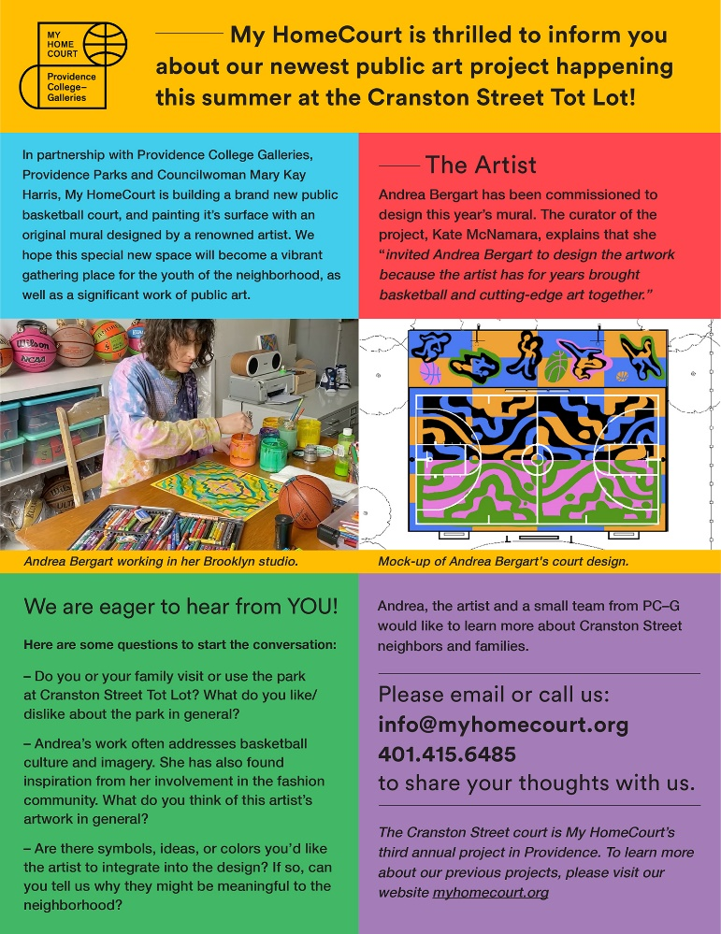
OTHER OUTREACH – We have worked with Property Management to mail out an update to Codding Court residents on the upcoming new basketball court being built next door to the development by the City of Providence in partnership with MyHomeCourt. A New York artist is coming in to paint a mural on the court as part of the project and the update asked tenants to get in touch to learn more and be able to provide their feedback on the project
We are also working on an outreach plan (including direct mail) to connect to families with a child of age to enter Kindergarten in September to be aware of a Kindergarten preparation program run by Inspiring Minds. The program has been adapted for COVID-19, with materials that will be delivered to parents that they can work on with their children over the summer as well as virtual interactive sessions.

COMMUNITY PROJECTS
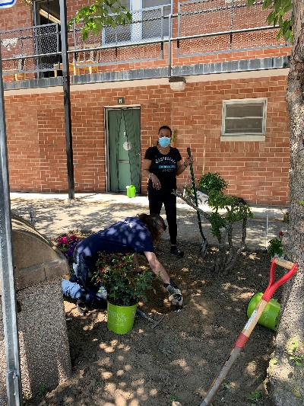
OSD is working with tenant leaders at Sunset Village who have restarted a garden committee to beautify the development with plantings. The group is meeting and working together on the plantings in a socially distanced fashion, with support from our office as well as Facilities Management.
A Spanish language version of this flyer went to all Codding tenants as well

